- Title of the invention
"Method for Identifying Novel Cancer Targets Using Machine Learning, Foundation Models, and Applications Thereof"
- Background of the invention
Cancer is a genetic disease in which cancer cells acquire a set of functional capabilities by genetic and epigenetic alterations altering their healthy trajectory into a disease state. Cancer is treated with drugs that block specific functional capabilities of cancer cells. Therefore, cancer target discovery relies on discovering biological regulators driving these aberrant functional capabilities.
Less than 1% of the ~22,000 human genes have been directly linked to cancer, of which Less than 25% are targets of approved therapies. The 102 approved cancer antibodies target 48 genes indicating more than one antibody against specific targets. For example, the immune checkpoint inhibitor PD-1 has seven approved antibodies and 32 antibodies in clinical trial. This observation underscores an important unmet need in cancer treatment, which is the lack of sufficient targets to treat cancer.
Biological data combined with Integrative analyses tools have identified over 50% of the current targets and has been a key driver of drug development since early 2000. However, these pipelines were not built to treat cancer holistically, rather it provided the scientists with a snapshot of the disease. Given that cancer is highly heterogeneous in its cellular composition, functional states, and biochemical and molecular properties, other approaches are needed to build more insightful disease models.

- Summary of invention
The present invention leverages AI-based tools to systematically identify and validate therapeutic targets and combine them to elicit additive/synergistic biological responses. Using advanced artificial intelligence models, such as the Single-cell Generative Pretrained Transformer (scGPT), insights from single-cell omics data is translated to uncover complex relationships between genes, cells, and diseases. These relationships are then interrogated to identify unique biological features that distinguishes disease from healthy and between progressive disease states. By providing a holistic representation of the healthy and diseased tissues, the invention facilitates the discovery of novel therapeutic targets and expands the target repertoire beyond conventional approaches.
Drug discovery has historically capitalized on changes specific to diseases, such as cancer that are not observed in non-cancer tissues. Examples include genetic alterations frequently identified in cancer cells but absent in non-cancer cells, or genes highly overexpressed in cancer cells with little to no expression in non-cancer cells. By identifying tumor-specific vulnerabilities, this invention enables the development of targeted therapies that can enhance therapeutic efficacy, reduce toxicity and improve outcomes.

These and other embodiments, features, and advantages will become apparent to those skilled in the art when taken with reference to the following more detailed description of various exemplary embodiments of the present disclosure in conjunction with the accompanying drawings.
- Brief Description of the Drawings
The skilled person in the art will understand that the drawings, described below, are for illustration purposes only.
Figure 1. Depicts an exemplary data analysis workflow according to the methods described herein.
Figure 2. Depicts an exemplary workflow for fine tuning foundation models to develop biologically meaningful inferences between genes
Figure 3. Depicts an exemplary gene relationship network based on cosine similarities between gene embeddings as determined according to the methods described herein.
Figure 4. Depicts exemplary prioritization strategies for druggable target discovery according to the methods described herein.
Figure 5A. Depicts an exemplary heatmap showing changes in the relationship score between genes when transitioning from Normal or Non-cancer (NC) to adenocarcinoma in situ (AIS).
Figure 5B. Depicts exemplary gene-relationship networks created from shifts in embeddings between NC and AIS according to the methods described herein.
Figure 6A. Depicts an exemplary heatmap showing changes in the relationship score between genes in NC and minimally invasive adenocarcinoma (MIA)
Figure 6B. Depicts exemplary gene-relationship networks created from shifts in embeddings between NC and MIA according to the methods described herein.
Figure 7A. Depicts an exemplary heatmap showing changes in the relationship score between genes in NC and Invasive adenocarcinoma (IAC).
Figure 7B. Depicts exemplary gene-relationship networks created from shifts in embeddings between NC and IAC according to the methods described herein.
Figure 8A. Depicts an exemplary heatmap showing changes in the relationship score between AIS and MIA.
Figure 8B. Depicts exemplary gene-relationship networks created from shifts in embeddings between AIS and MIA according to the methods described herein.
Figure 9A. Depicts an exemplary heatmap showing changes in the relationship score between genes in MIA and IAC.
Figure 9B. Depicts exemplary gene-relationship networks created from shifts in embeddings between MIA and IAC according to the methods described herein.
Figure 10. Depicts an exemplary strategy to combine bulk and single-cell RNA-seq data to discover novel relationships between genes according to the methods described herein.
Figure 11. Depicts CTLA-4 and TIGIT co-expressing T cells in different lung cancer stages revealed by the gene network relationship according to the methods described herein.

- Detailed Description of the Invention
For clarity of disclosure, and not by way of limitation, the detailed description of the invention is divided into the subsections that follow.
Unless defined otherwise, all technical and scientific terms used herein have the same meaning as is commonly understood by one of ordinary skill in the art to which this invention belongs. All patents, applications, published applications and other publications referred to herein are incorporated by reference in their entirety. If a definition set forth in this section is contrary to or otherwise inconsistent with a definition set forth in the patents, applications, published applications and other publications that are herein incorporated by reference, the definition set forth in this section prevails over the definition that is incorporated herein by reference.
As used herein, “a” or “an” means “at least one” or “one or more.”
As used herein, the term “and/or” may mean “and,” it may mean “or,” it may mean “exclusive-or,” it may mean “one,” it may mean “some, but not all,” it may mean “neither,” and/or it may mean “both.”
Two transformative technological advances have set the stage for building more insightful models of cancer and other diseases. The first is the availability of single-cell omics data, derived from both healthy and diseased cells. By February 2025, public repositories had amassed single-cell transcriptomic data from over 90 million cells, providing an unprecedented resource for understanding cellular heterogeneity and the intricate molecular mechanisms underlying health and disease.
The second breakthrough is in artificial intelligence (AI), specifically with the advent of Foundation Models (FMs) and Large Language Models (LLMs). These cutting-edge AI systems provide robust platforms for uncovering and mapping complex relationships among biological entities, such as gene-gene, gene-cell, cell-cell, cell-disease, and gene-disease interactions. The present inventors have found that insights obtained from this deeper understanding can facilitate the identification of novel patterns and inferences, and drive breakthroughs in our comprehension of healthy and diseased states according to the methods described herein.
The present disclosure provides methods by which AI can be used to parse complex relationships between genes, cells, and diseases to extract biologically meaningful relationships that can be exploited for developing novel therapies, or combine known therapies more effectively, or discover disease-related biomarkers that are predictive, diagnostic, or prognostic.
The present methods leverage a type of AI-model referred to as Foundation model to reveal biological relationships between two or more genes in any human disease, where single-cell gene expression data is available from diseased or non-diseased samples. Single-cell gene expression captures the level of expression of genes in individual cells isolated from diseased or non-diseased samples, or diseased and non-diseased tissues from the same patient (matched samples). Technologies that enable generating data from single cells combine a method of capturing single cells from a pool of cells, a method of generating transcriptome libraries from each cell, barcoding libraries with unique barcodes and unique molecular identifiers (UMI) and sequencing the libraries on a sequencing platform. Pipelines to analyze single cell data are available in open source, which can be deployed to analyze single-cell RNA-seq (transcriptome) data.
The output of single cell RNA-seq data is a count matrix table. The count matrix table from single-cell gene expression analysis is a numerical representation, where rows correspond to genes, columns correspond to individual cells, and each entry indicates the number of detected transcripts (UMI counts or read counts) for each gene in each cell.
The present method transforms the count matrix data generated by single-cell transcriptomic analysis pipelines into biologically meaningful relationships as shown, for example, in Figure 1. A brief description of exemplary the steps according to the present methods is given below.
- Data pre-processing
This step involves applying quality control filters to ensure data reliability. The foundation models have a criterion to filter out cells that do not express a minimum number of genes. For example, cells expressing fewer than 200 genes may be considered low-quality and removed from the dataset. After filtering, the data is normalized using log transformation to account for differences in sequencing depth and improve comparability across cells. For instance, gene expression values are transformed as log1p(X) = log(1 + X), where X is the raw gene count. This transformation stabilizes variance and makes downstream analysis, such as clustering or dimensionality reduction, more effective.
The result of this step is a dataset containing only high-quality cells with normalized gene expression values. Low-expressed cells are filtered out, and the refined data is carried forward for further analysis, such as embedding generation or clustering.
- Applying Foundation model to generate gene embeddings
Foundation Models function similarly to large language models (LLMs), processing text and multimodal data to summarize, annotate, classify, and perform various other tasks. These models are designed to integrate multiomic data, combining diverse biological information from multiple sources. They incorporate large-scale genomic sequences (DNA-level data), transcriptomic profiles (gene expression data from RNA), and proteomic data (protein expression and interactions). Additionally, they leverage textual information related to genes, cells, diseases, drugs, and treatments. This comprehensive approach enables a deeper understanding of biological systems. These models extract biological knowledge as embeddings, which are mathematical representations of concepts like genes, cells, and tissues, projected as vectors in a multi-dimensional feature space and exhibit surprising properties. Embeddings are numerical representations learned by the neural network during training, capturing meaningful biological relationships in a lower-dimensional space. In this space, genes with similar functions (e.g., those in the same pathway or co-expressed) cluster together, as do cells of the same type. Healthy and diseased cells naturally form distinct clusters, and the distances between them carry biological significance.
For example, by analyzing these distances, one could design gene perturbations to shift a diseased cell’s embedding toward a healthy state. This approach can be applied to drug discovery, identifying potential targets by silencing genes or testing for synthetic lethality pairs—where knocking out two genes together is lethal to a diseased cell but not a healthy one. These learned embeddings thus provide a powerful tool for understanding biological mechanisms and therapeutic interventions.
It is important to observe that to-date, models trained on large, diverse datasets encompassing multiple diseases, tissues, and cell types have failed to generate meaningful, actionable insights for a specific disease condition involving a selective tissue type. To address this limitation, the presently described Foundation Models are, among other adaptations described herein, fine-tuned on datasets tailored to a particular biological phenonemon.
In present disclosure, the Foundation model
is fine-tuned using a lung cancer dataset comprising paired non-cancer and cancerous tissues from multiple individuals. These individuals presented with different stages of lung cancer, including early-stage adenocarcinoma in situ (AIS), minimally invasive adenocarcinoma (MIA), and invasive adenocarcinoma (IAC). Fine-tuned the neural network with this dataset generated new embeddings, reshaping the feature space and uncovering relationships that were not present in the original, non-fine-tuned model. These newly identified relationships were then filtered using specific criteria and subjected to downstream analysis (Figure 2).
Unfiltered relationships are dense and do not provide actionable insights, as depicted in Figure 3. Therefore, the present inventors developed and applied filtration strategies shown in Figure 4. The present inventors utilized an exploratory approach to identify shifts in embeddings between non-cancer and cancer samples and use significantly shifted gene embeddings to create network (section 6a). In a second more directed approach, the present inventors used known oncogenes and tumor suppressor genes in lung cancer and built relationships using embeddings from the model (section 6b). As a third approach, the present inventors built relationships between genes targeted by approved antibody drugs in lung cancer to identify potential combinations that has not been considered in the current drug development pipelines and are immediately actionable (section 6b). In the fourth approach, we show how our method provides biological insights and novel therapeutic strategies to target lung cancer by combining bulk and single-cell RNA-seq data using a foundation model (Figure 10, section 6c).
- Relationship networks and Embedding changes
- Relationship Networks
Relationship networks are constructed using gene embeddings generated from data at each stage of lung cancer. To build these networks, we calculate the cosine similarity between every pair of gene embeddings and initially connect all genes to each other. However, this results in an overly dense and uninformative network where many weak connections dilute meaningful biological insights. To refine the network and highlight the most relevant gene relationships, we employ two key methods: cosine similarity thresholding and ranking-based selection.
In cosine similarity thresholding, a predefined similarity threshold is set, and only gene pairs with a cosine similarity greater than or equal to this threshold are retained. For example, if the threshold is set to 0.8, only gene pairs with a similarity score of 0.8 or higher remain connected. This ensures that only the most strongly related genes form interactions within the network, making it easier to interpret meaningful biological associations. If two genes, such as Gene A and Gene B, exhibit a similarity score of 0.85, their connection is preserved, whereas a pair with a lower similarity of 0.6 is excluded.
The ranking-based approach, on the other hand, does not rely on an absolute similarity threshold but instead selects the top n most similar connections for each gene. The connections are ranked from the highest similarity down to the nth strongest connection. For instance, if n = 10, each gene will be linked to its 10 most similar genes based on cosine similarity. This method ensures that all genes maintain a fixed number of connections, even if their absolute similarity values vary. For example, if Gene X has its highest similarity with Gene Y (0.92) and the lowest among the top 10 with Gene Z (0.78), the network retains only these 10 connections. This approach is particularly useful in cases where biological relationships need to be interpreted based on relative rather than absolute similarities. By filtering out weaker or less relevant connections, these refined networks help in identifying gene interactions that play crucial roles in disease progression, biomarker discovery, and therapeutic target identification.
Embedding Changes
Gene embeddings capture not only expression levels but also functional relationships. Through fine-tuning, embedding changes reveal three key scenarios: genes that stop being expressed, genes that become newly expressed, and genes that maintain expression but undergo functional shifts. Traditional differential expression analysis detects only the first two, whereas embedding-based analysis identifies functional changes even when expression remains constant.
For example, a gene may retain the same expression in both healthy and diseased tissues but lose connections with tumor-suppressor genes while forming new links with oncogenes. Cosine similarity quantifies these shifts, where lower similarity values indicate greater functional changes. A heatmap-based visualization highlights these shifts, helping identify key genes in disease progression and potential therapeutic targets.
We can also construct relationship networks specifically for genes identified as having significant shifts when transitioning from normal to tumor states. By focusing only on these functionally altered genes, we can gain clearer insights into how disease progression rewires biological interactions, helping pinpoint critical regulatory changes and potential intervention points.
In the next section the utility of the four approaches
- Examples and Embodiments
  - Utility from differential embedding analysis
As shown in the heatmap (Figure 5A), 19 (arrows) of the 29 genes showed embedding shifts going from non-cancer to adenocarcinoma in situ (AIS). The embedding shifts indicates relationship changes between two genes where the shift can be either from weak in non-cancer to strong in cancer (deep blue) or weak in cancer to strong in non-cancer (deep red).
A network built on embedding shifts is shown in Figure 5B. An example using VEGFA and HIF-1α (indicated by a circle) showed a blue shift suggesting stronger relationship in cancer compared to non-cancer. Both VEGFA and HIF-1α are known to be linked functionally, where the HIF-1α transcription factor induces VEGFA expression under a hypoxic environment. VEGFA expression induces new blood vessel growth required to support tumor growth. We observed a VEGFA and HIF-1α relationship that is strong in early-stage tumor (AIS), but disappearing in minimally invasive adenocarcinoma (MIA) and invasive adenocarcinoma (IAC). However, in invasive tumors (IAC) VEGFA-HIF1-α is replaced by a new relationship between VEGF receptor FLT1/VEGFR2 with HIF1-α. This shift is explained from the knowledge in the art that VEGFR2 is transcriptionally induced by VEGFA signaling creating a feed-forward loop to promote angiogenesis. Multiple angiogenesis blocking drugs, (VEGFA-binding antibody bevacizumab and FLT1/VEGFR2-blocking antibody (ramucirumab) are approved to treat lung cancer. Small molecule inhibitors blocking HIF-1α pathway are currently evaluated for efficacy in multiple clinical trials. Our analysis suggests that blocking angiogenesis in early-stage lung cancer can be achieved by mopping up VEGFA using bevacizumab whereas in late-stage metastatic tumors combining FLT1/VEGFR2 blocking antibody ramucirumab with HIF-1α inhibitors will be more effective. Taken together, relationships between genes can be leveraged to repurpose approved therapies and create personalized treatment modalities.
The presently described methods provide means for identifying cancer-stage-specific novel drug targets, as well as targets that can be combined most effectively to treat a specific disease stage. Our methods also provide a rationale for creating multivalent antibodies (bispecific and multispecific) to treat refractory and recurrent tumors by leveraging changes in relationships between genes during cancer progression. This approach has identified embedding shifts between genes and gene-relationship network between non-cancer and MIA tumors (Figure 6A-B) and between non-cancer and IAC samples (Figure 7A-B).
The presently described approach provides a platform approach that, with the use of single-cell transcriptome data, is applied to any cancer to identify and implement novel therapies or identify and utilize drugs for particular cancers in a novel manner. According to certain embodiments, single-cell transcriptome data is generated as a first step for a particular cancer type or state according to the described methods. The approach can be extended to other diseases beyond cancer where significant gene expression changes have been observed between healthy and disease samples. For example, in Lupus, a bispecific antibody targeting two antigens CD19 and FcγRIIb on B cells is tested in clinical trials. These two genes are overexpressed in lupus. Approved antibodies, protein or peptide therapeutics, and/or small molecule inhibitor/activator drugs can be used to target relationship networks identified according to the presently described methods that are linked to disease pathways.
  - Gene-centric prioritization
In another embodiment, we discovered novel relationships between oncogenes or tumor-suppressor genes in lung cancer and identified novel interactions for therapeutic intervention or for the development of novel drugs. According to this embodiment, the present inventors evaluated relationships that were differentially shifted between non-cancer and cancer samples. Such a shift has been found to take any of the following alternatives:
- Absent in non-cancer but present in cancer
- Lower rank in non-cancer (high rank score) but higher rank in non-cancer (lower rank score)
To demonstrate the utility of the present embodiment, we extracted top-10 ranked binary relationships between EGFR, a well characterized oncogene in lung cancer and a target of antibody and small molecule inhibitor drugs. Table 1 shows EGFR and its relationship with other genes in non-cancer and tumors from three lung cancer stages. Each gene pair has a rank calculated from their cosine similarity.
Table 1. Novel targetable therapeutic combinations revealed from the relationship network
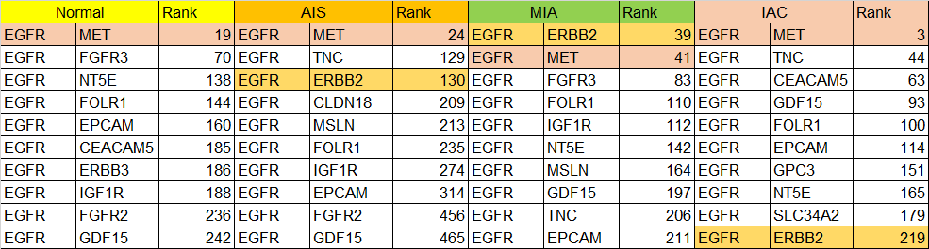
We selected the gene pairing of EGFR and MET in this exmaple. Both EGFR and MET are targeted by an approved bispecific antibody drug Amivantamab in lung adenocarcinoma. Table 1 shows that in non-cancer tissues EGFR-MET has a rank score of 19 that decreased to 3 in invasive carcinoma, suggesting that the cosine similarity between the two genes increased moving from non-cancer to invasive disease. This increase in cosine similarity (which pushed the rank from 19 to 3) implicates that that these two genes are functionally brought closer to each other in invasive disease. The biology of EGFR and MET supports this finding, given that advanced cancer has a propensity to metastasize and MET is well characterized for its role in cell migration. Cancer cells co-expressing both the oncogenes EGFR and MET are likely to migrate and survive outside the lung environment. In the context of use of Amivantamab, the drug is approved in metastatic non-small cell lung cancer harboring activating mutations in EGFR.
A second example to support a combination therapy between approved drugs involves the gene pairing of EGFR and ERBB2. In early-stage non-small cell lung cancer, EGFR-ERBB2 is low in rank the in non-cancer tissue (rank 873), t its rank advances in adenocarcinoma in situ (rank-130) and further improves in mildly invasive carcinoma (rank-39). The two receptors however, become functionally less relevant as the tumor transitions to more aggressive tumor (rank 219) (Table 1). Taken together these two examples suggest that for early and mildly invasive lung cancer a combination of EGFR-ERBB2 targeting inhibitors will have better efficacy, whereas in late-stage, invasive adenocarcinoma targeting EGFR-MET may be more efficacious.
  - Novel biology discovered from differentially overexpressed genes using a foundation model
Differential gene expression between non-cancer and cancer tissues has driven the discovery of many drugs to treat cancer. However, the approach falls short in providing a rationale for combination therapies that could rescue patients whose tumors have become refractory and/or patients whose cancer has relapsed from a therapy. Table 2 shows the top differentially upregulated genes in lung adenocarcinoma based on our analysis of bulk RNA-seq data according to the present methods.

Table 2. List of upregulated genes in Lung adenocarcinoma compared to normal (non-cancer) lung tissue from bulk RNA-seq data
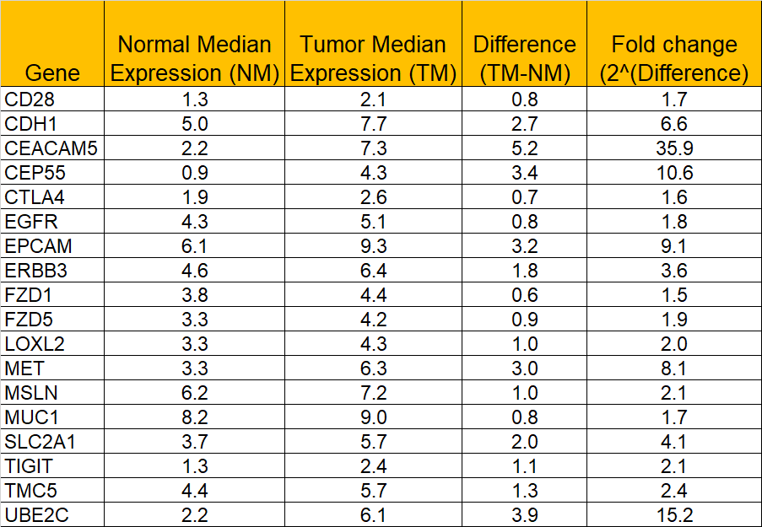
We suggest a novel approach to combine the differential gene expression analysis with single-cell transcriptomic data, bridging the two datasets using a foundation model. The approach is shown in Figure 10. In this approach, the first step is to identify the differentially overexpressed genes (>1.5-fold overexpression) by comparing the expression of 18,000 genes in normal lung vs lung cancer. The list of differentially overexpressed genes shown in Table 2 are analyzed against single-cell transcriptome data generated from normal lung and the three lung cancer stages (AIS, MIA and IAC) using a foundation model. The goal was to capture any changes in their relationships between healthy lung tissue vs each of the three stages of lung cancer as shown in Figure 10
Among the overexpressed genes shown in Table 2, we focused on two checkpoint inhibitor genes, CTLA-4 and TIGIT, to show the utility of the present method. Checkpoint inhibitors have become the standard of care treatment in lung cancer with antibodies to CTLA-4 (ipilimumab), PD-1 (nivolumab and pembrolizumab) and PD-L1 (atezolizumab and durvalumab), which are all approved to treat this indication. Combinations of CTLA-4 and PD-1 antibodies have shown significant improvement in outcome and are approved in non-small cell lung cancer. We analyzed the relationship table and filtered all binary relationships between CTLA-4, other checkpoint inhibitors, and immune genes in non-cancer healthy lung and samples from three cancer stages. The number of binary relationships detected between CTLA-4 and other genes ranged from 116 in non-cancer, 92 in AIS, 97 in MIA and 89 in IAC. We selected top-10 interactors by score from each of these tissues as shown in Table 3.
Table 3. Top-10 CTLA4 interactors reveal changes in the immune microenvironment from non-cancer (NC) to a progressive disease (IAC)
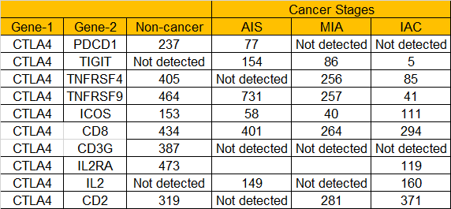
As shown in Table 3, non-cancer, and early-stage cancer (AIS) show a relationship between CTLA-4-PD-1 whose rank order decreases from 237 (lower rank) in non-cancer tissue to 77 (higher rank) in early-stage cancer. However, in mildly invasive (MIA) and invasive samples (IAC) CTLA-4-PD-1 relationship is replaced by CTLA-4-TIGIT, whose rank order decreases from 86 in MIA to 5 in IAC implicating a newer phenotype of exhausted T cells. The three genes CTLA-4, PD-1 and TIGIT are checkpoint inhibitors whose function is to suppress activated T cells and bring them to their non-activated or basal state. T cells co-expressing different markers represent different phenotype of T cells with different functional significance. To support our hypothesis that indeed IAC tumors contain a higher proportion of CTLA-4⁺/TIGIT⁺ cells we quantitatively estimated the number of T cells that co-expressed the two markers. As shown in Figure 11, the proportion of T cells expressing CTLA-4 and TIGIT was five fold higher in invasive carcinoma (IAC) than in AIS and MIA (Figure 11)
This shift in the phenotype of T cells revealed by a switch in CTLA-4/PD-1 expressing T cells in non-cancer and early-stage disease (AIS) to CTLA-4/TIGIT expressing T cells in more invasive tumors e is a novel finding of the present study. T cells co-expressing CTLA-4/PD-1 represent exhausted/suppressed T cells that have gone through a cycle of activation in the tumor microenvironment. These cells are targeted by a combination of anti-CTLA-4 andanti-PD-1 blocking antibodies. The use of these antibodies bring the T cell back to an active state where they mediate tumor control. The efficacy of the combination therapy has been demonstrated in Phase-III study of metastatic melanoma where the combination of ipilimumab (anti-CTLA-4) and nivolumab (anti-PD-1) scored 11.5 progression free survival compared to 2.9 months with ipilimumab monotherapy or 6.9 months with nivolumab monotherapy (NEJM 2018, vol. 379, 2185).
The CTLA-4/TIGIT co-expressing T cells on the other hand, represent a highly immune-suppressive T cell population, having functional characteristics of T_{reg} (T-regulatory) cells. While not intending to be bound by any specific theory of operation, it is believed that unlike the CTLA-4/PD-1 co-expressing T cells, these cells could suppress other immune cells in the tumor microenvironment. The presence of these cells in mild invasive (MIA) and invasive adenocarcinoma (IAC) indicates a tumor that is unlikely to respond to PD-1 therapy but is likely to be sensitive to dual CTLA-4/TIGIT inhibition. The recent failure of TIGIT blocking antibodies as monotherapy or in combination with PD-1 (Merck Provides Update on KeyVibe and KEYFORM Clinical Development Programs Evaluating Investigational Vibostolimab and Favezelimab Fixed-Dose Combinations with Pembrolizumab - Merck.com) or PD-L1 (Tiragolumab/Atezolizumab for NSCLC Fails to Meet End Points in SKYSCRAPER-06) blocking antibodies in multiple pivotal trials demonstrates that incorrect and ultimately non-therapeutic combination therapies are being used for treatment of advance lung cancer (MIA and IAC). Our findings provide a therapeutic rationale as to why a combination of CTLA-4 and TIGIT blocking antibodies in invasive lung adenocarcinoma is likely to functionally block the more abundant suppressive T cells in the tumor microenvironment of more advanced tumors.
To test whether this strategy should have been obvious to others, we checked the Clinical Trials database for the number of non-small cell lung cancer trials testing ipilimumab (anti-CTLA-4) and nivolumab or pembrolizumab (anti-PD-1) and found 86 studies. There were no non-small cell lung cancer study testing ipilimumab and Tiragolumab (anti-TIGIT antibody).
Claims
1. A method for identifying novel drug targets and druggable target combinations using single-cell transcriptome data and a foundation model, comprising:
a) Obtaining single-cell RNA sequencing (scRNA-seq) data from early, mid, and late-stage lung cancer samples;
b) Processing the scRNA-seq data to generate gene expression profiles for individual cells;
c) Applying a foundation model trained on transcriptomic and biological datasets to generate gene embeddings;
d) Determining shifts in gene embeddings across different cancer stages to identify changes to identify novel drug targets and druggable target combinations;
2. The method of claim 1, further comprising using machine learning models to prioritize drug
targets based on cellular localization, function in cancer, and known druggability.
3. A method for drug repurposing in lung cancer treatment using gene embeddings, comprising:
a) Extracting gene embeddings from a foundation model using single-cell transcriptome data of lung cancer samples;
b) Comparing the gene embeddings of known drug targets across different cancer stages to identify shifts indicating potential therapeutic efficacy;
d) Validating the repurposed drugs through in silico or in vitro methods.
The method of claim 3, wherein the repurposed drugs are further filtered based on patient-specific transcriptomic profiles to create personalized treatment recommendations.
4. The method of claim 3, wherein the repurposed drugs are further filtered based on patient-specific transcriptomic profiles to create personalized treatment recommendations.
5. A method for personalized medicine in lung cancer patients based on single-cell transcriptomic data, comprising:
a) Collecting single-cell RNA sequencing data from a patient’s tumor sample;
b) Processing the data to obtain a patient-specific gene expression profile;
c) Utilizing a foundation model to generate gene embeddings and detect embedding shifts unique to the patient;
d) Comparing the patient's gene embeddings with druggable gene targets to identify tailored therapeutic interventions;
e) Generating a personalized treatment plan based on the identified drug targets, druggable combinations, or repurposed drugs.
6. The method of claim 5, further comprising dynamically updating the personalized treatment plan based on longitudinal transcriptomic data to adapt to disease progression or treatment response.

